#include <stdio.h>

#include <string.h>

#include <stdlib.h>

//Franklyn Gonzalez, last edited 02/23/2019

//Resume Keyword Finder v1.0 - This program will provide you with the basic needs in qualifying your next candidate. Please note, when creating a keyword.txt document, provide a comma after the keyword. String case sensitive keywords are counted. This program excludes ':', '(' , ')' , '\n' , ' ' , '.'

void keywordGenerator(FILE *fp1, FILE *fp2, char keyword[])

{

char resume[200] = { '\0' };

int words = 0; // number words matched from the keyword.txt to the resume.txt

int count = 0;

for (int i = 0; i < 14; i++) // 14 is the value set for the amount of keywords in the file. Modify 'i' length as needed for keyword.txt

{

for (int j = 0; j < 15; j++)

{

keyword[j] = getc(fp2);

if (keyword[j] == ',') { //commas used to stop 'for' loop

keyword[j] = '\0'; // replaced with a null character

j = 15; // loop-end

}

}

while (count != 200) // count is used to stop the loop after a certain amount of words in the resume have been reached

{

count++;

for (int i = 0; i < 25; i++)

{

resume[i] = getc(fp1);

if (resume[i] == ' ' || resume[i] == '\n' || resume[i] == '(' || resume[i] == ')' || resume[i] == ':' || resume[i] == '\0' || resume[i] == '.') //special characters excluded, other special characters next to keywords may not be detected

{

resume[i] = '\0'; // replaced with a null character

if (strcmp(keyword, resume) == 0) // compares the two character arrays

{

words++;

}

i = 25; // end loop

}

}

}

count = 0;

fclose(fp1); // close resume file

FILE *fp1 = fopen("C:\\MyFiles\\Resume.txt", "r"); // re-open resume file

}

printf("Total Keywords found in both files: %d\t", words); // keywords found in resume

}

int main()

{

FILE *fp1 = fopen("C:\\MyFiles\\Resume.txt", "r"); //open resume file

FILE *fp2 = fopen("C:\\MyFiles\\Keywords.txt", "r"); //open keyword file

char keyword[15][20] = { '\0' }; // array used to store keyword characters

if (fp1 == NULL || fp2 == NULL) // if an error occurrs, a notification will appear

{

printf("ERROR: The files could not be opened!");

exit(-1);

}

keywordGenerator(fp1, fp2, keyword); //call compareFiles

fclose(fp1); // close resume file

fclose(fp2); // close keyword file

return 0;

}

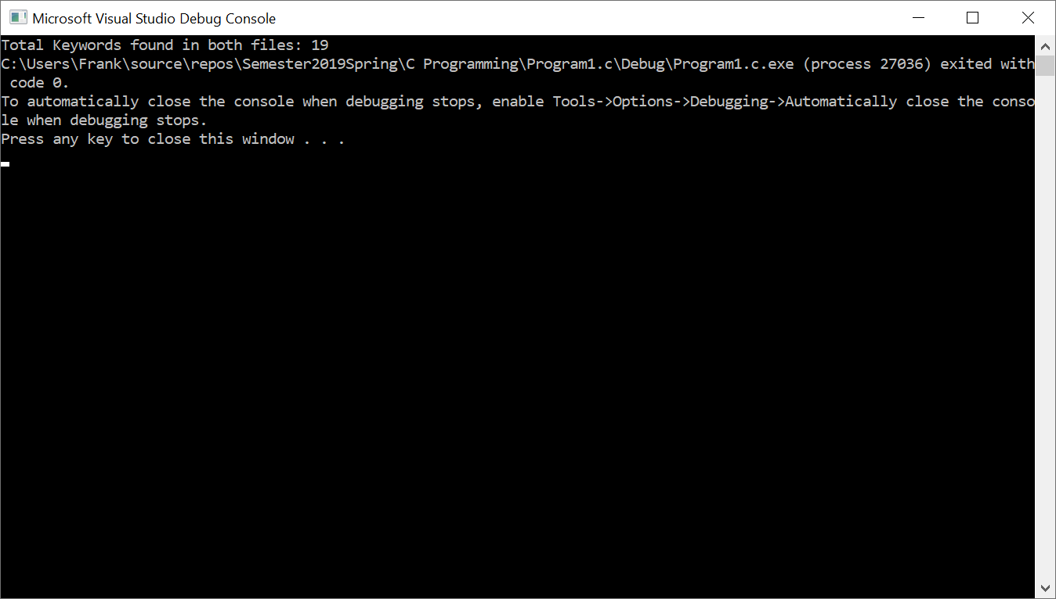

|  |  |  |
| --- | --- | --- |
| **Input**  Count  keywordGenerator  word  resume[i]  keyword[j]  *fp1  *fp2 | **Processing**  🡪 counts number of words and newline characters in resume for ‘while’ loop🡪  🡪 calls function and carries “keyword, *fp1, and *fp2” values🡪  🡪 number of keywords from resume🡪  🡪 counts characters in resume.txt🡪  🡪 counts characters in keyword.txt🡪  🡪 points to resume.txt🡪  🡪 points to keyword.txt🡪 | **Output**  Outputs 198 at the end of file  Points to resume.txt and keyword.txt, uses keyword[j]  Outputs 19 keywords  Outputs strings without spacing or special characters  Outputs strings without spacing or special characters  Reads file from getc()  Reads file from getc() |